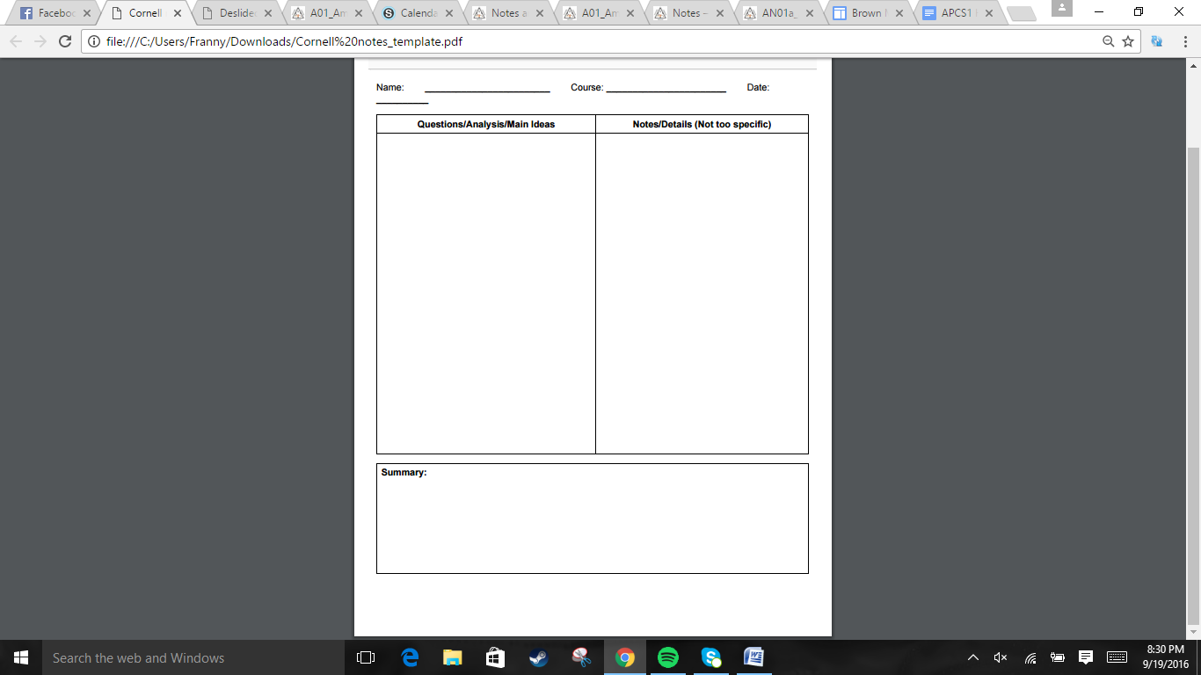  
  
  
  
  
  
  
  
  
  
  
  
  
  
  
  
  
  
  
  
  
  
  
  
  
  
  
  
  
  
  
  
  
  
  
  
  
  
  
  
  


The British decided to repay their war debts by increasing taxes placed on the colonies. The colonists become angry as a result. To control the colonies, the British bring troops over, which only enrages the colonists even more. Eventually, the colonists clash with the British military.

. Britain taxed the colonists even more to pay their war debts. There was the 1765 Stamp Act, which required the paper of legal documents to be written to be purchased from stamped paper. Those caught breaking this law were tried in vice-admiralty courts. This leads to the 1765 Stamp Act protests => Samuel Adams founds the Sons of Liberty => harassed government workers and protested stamps => colonists argue that they had no need to follow those stamp act rules because they had no representation in the government. => 1776, act repealed.  
.Townshend acts => duties levied on imported materials and tea. Colonists angry about taxation without representation. British agents claimed Hancock's ship, the *Liberty*, had smuggled wine without paying taxes => Riots from colonists => 2k British soldiers stationed in Boston  
.Boston Massacre : Colonists gather in front of customs house and taunt the guards. 3 men died and 2 were fatally injured. Then in 1772, colonists attack a British customs schooner => King George seeks out suspects to bring to England => Colonies set up committees of correspondence = information network.  
.The Boston Tea Party due to the Tea Act eventually leads to Boston being put under the Intolerable Acts, British commanders could house soldiers in anyone's homes and Boston was placed under martial law. The committees assemble First Continental Congress.  
.General Gage finds out about the resistance hiding weapons in Concord and Hancock and Samuel Adams staying in Lexington. Joseph Warren informs Paul Revere, Dawes, and Prescott to warn others about the British Regulars. The British lose the element of surprise. Although they win two skirmishes, they eventually get slaughtered by the militia in Concord.

Jonathan Quang US History 9/29/2016

Section 1: The Stirrings of Rebellion

Why did the colonies resist Britain?  
  
  
  
  
  
  
  
  
  
  
  
How did tensions increase in Massachusetts?  
  
  
  
  
  
  
What happened at Lexingon and Concord?

.In the Second Continental Congress, John Adams wanted each colony to set up its own government and for Congress to declare the colonies independent. Others disagreed about revolting. Eventually, Congress appoints George Washington as the commander of the Continental army. It also acts like an independent government. Then, the battle of Bunker Hill happened where the British succeed on their third assault. In 1755, Congress sent the Olive Branch Petition that urged the king to return to former harmony. King George rejected it.  
. Thomas Paine made the pamphlet *Common Sense,* which attacked King George and talked about American independence. In the summer of 1776, numerous colonies were nearing declaring independence at the urge of Congress. It appoints Thomas Jefferson to write up the Declaration of Independence, which drew on John Locke's philosophies. Delegates unanimously voted on it in July 2, 1776, which was adopted on July 4, 1776. The document was read to a crowd in front of the Pennsylvania States House. Independence Hall  
.There were Loyalists who remained with the Crown because of their government positions, there were uninformed, though British would win, and/or British could protect them better.  
.Patriots believed in the economic opportunity of an independent America. Some slaves fought for the British because they were promised freedom, others for Patriots. Natives fought for the British because the colonists were the more immediate threat.

Section 2: Ideas Help Start a Revolution  
What happened during the period between peace and war?  
  
  
  
  
  
What events surrounded the colonists declaring independence?  
  
  
  
  
  
What sides did Americans choose?

Jonathan Quang US History 9/25/2016

Congress becomes more unified and starts acting like an independent government. Documents about American independence were publicized. This split the population between Patriots, Loyalists, and neutrals.



. General William Howe and Admiral Richard Howe attack NY harbor pushing Washington back all the way to Pennsylvania. He went from 23K men to 8k men. On Christmas of 1776, Washington rowed across the Delaware to Trenton, New Jersey where he finally got a victory in a surprise attack against drunk Hessians. Washington got another victory in Pinceton, then he marched to Morristown.  
.General Howe captures Philadelphia, so the Continental Congress flees. Meanwhile, General Burgoyne decided to join up with Howe by going from Canada to Albany. The extra equipment made going across swamps and gullies slow, food also ran low. General Horatio Gates was appointed to combat Burgoyne, whom lost in every battle and surrendered at Saratoga. => Britain switches strategies, keeping to the coast. France supports the Americans openly now that they look like they can win.   
.Congress printed more money => inflation. Some government officials engaged in profiteering. To counter economic struggles, Morris and Salomon raise enough funds to finally pay troops in gold coin. While men were at war, women took over responsibilities of men and also supported soldiers during the war.

Section 3: Struggling toward Saratoga|/

How does the war move from the northern colonies to the middle colonies?

What was colonial life like during the revolution?

Jonathan Quang US History 9/22/2016

The war for independence was looking grim as the British push Washington back to the middle colonies. However, a series of victories draws support to the colonies. During the war, the colonies underwent financial struggles.



Jonathan Quang US History 9/23/2016

.Friedrich von Steuben drilled American soldiers to become more effective. Marquis de Lafayette lobbied for French reinforcements and led a command in Virginia for the latter part of the war.  
Charles Cornwallis and Henry Clinton capture Charles Town, South Carolina. Clinton left for NY, while Cornwallis went on to defeat Americans at Camden, South Carolina. Patriot harassment forces the British to retreat to South Carolina. Nathanael Green led the harassments .Eventually, Cornwallis lost 25% of his troops. Cornwallis also fails to capture the divisions of Layfette and Steuben. He decides to fortify Yorktown then take Virginia.  
.The French navy defeat the British fleet and block the entrance to Chesapeake Bay, preventing a British sea rescue. Americans surrounded Yorktown and bombarded them. Cornwallis surrenders. On October 19, 1781, Washington, the French, and troops assemble to accept British surrender. Peace talks began in Paris in 1782. The three nations + Spain enter negotiations, but America refuses to start until Britain gives them independence. September 1783, the Treaty of Paris was signed. Natives' were not protected, and state governments fail to honor Loyalists suing in court and British creditors collecting debts.   
.Egalitarianism for white males, ability, effort and virtue determined worth. Africans still enslaved, but more are released. Native Americans continue losing land.

Section 4: Winning the war  
How did other Europeans shift the balance of war?

What happened when the British move south?  
  
  
  
  
  
  
  
What led to the British Surrender at Yorktown?  
  
  
  
  
  
  
  
  
What changes result from the war?

European allies helped Americans to win the war. Cornwallis was pushed back, and he made the poor mistake of fortifying at Yorktown. His escape was cut off and was under siege. The British were forced to surrender, and the Americans got their independence with the Treaty of Paris.